**CP Club 365Days Challenge**

**Programming language – C++**

**Problem Statement**

<https://www.codechef.com/problems/CHNGIT>

**Your Code**:

// 0x70Day of 0x365Days challenge

// VEDANT BHARAD

// 26-12-2022

#include <bits/stdc++.h>

using namespace std;

int mostFrequent(int a[], int n)

{

    int maxcount = 0;

    int returnvalue = 0;

    for (int i = 0; i < n; i++) {

        int count = 0;

        for (int j = 0; j < n; j++) {

            if (a[i] == a[j])

                count++;

        }

        if (count > maxcount) {

            maxcount = count;

            returnvalue = count;

        }

    }

    return returnvalue;

}

void ChangeIt(int a[],int n) {

    int temp=mostFrequent(a,n);

    if(n==1 || temp==n)

    {

        cout<<0<<endl;

    }

    else

    {

        cout<<n-temp<<endl;

    }

}

int main() {

    int t;

    cin >> t;

    while (t--) {

        int n;

        cin>>n;

        int a[n];

        for (int i = 0; i < n; i++) {

            cin >> a[i];

        }

        ChangeIt(a,n);

    }

    return 0;

}

**Output (Screen Shot)**:

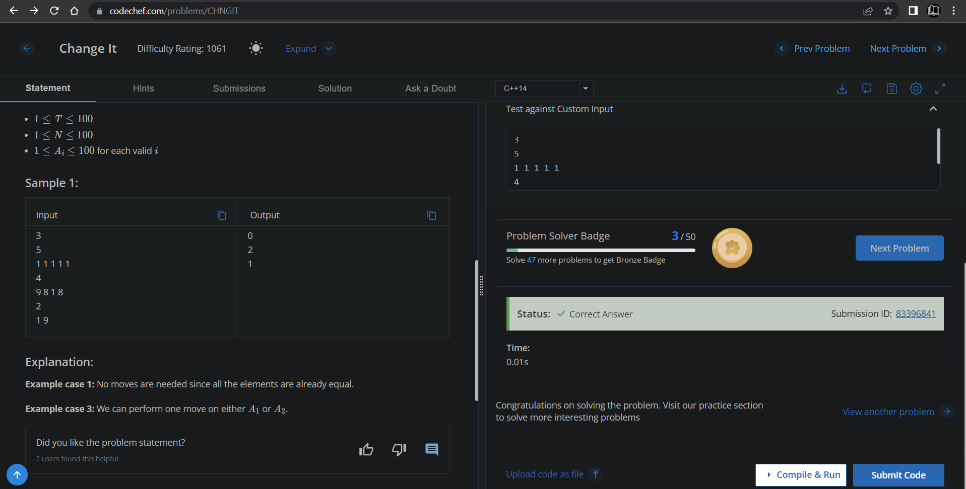

**Understanding about problem:**

* In this task there will be number of test case,length of array and array it self as a input.
* In this task I need to return the number which is the count of minimum moves to make all the element of the array equal.

Note: If you can't understand the problem, feel free to contact us and we'll help you. Please don't copy and paste from anywhere.

ALL THE BEST

Team CP Club